Fascism Concept Formation Instructions:
Clearly, succinctly, thoroughly, and collaborative define, defend, and create something you can turn in electronically via turnitin about your table group’s definition of Fascism.
- You have 45 minutes to complete this assignment!
- You may use any materials you want in this room, but please share them. You should use consider all of the articles provided and cite them in a method consistent with expectations of this class.
- EACH GROUP IS ALLOWED ONE COMPUTER to type up your answer, not to search the internet for answers
- THE PACKETS ON YOUR TABLE ARE CLASSROOM SETS,
  - YOU MAY TAKE THEM APART, BUT YOU NEED TO HOLD ON TO ALL THE DOCUMENTS AND BRING THEM BACK TO ME TO PUT BACK TOGETHER IN THE ORDER THEY CAME IN AT THE END OF CLASS.
- I WILL ANSWER CLARIFYING CONTENT QUESTIONS—THAT IS ALL!
- NO PHONES OR PERSONAL DEVICES OUT – I RARELY REQUIRE THIS SO PLEASE PUT IT AWAY WHERE YOU WONT GET DISTRACTED!
- DUE AT THE END OF PERIOD to TURNITIN.COM!

Article 1: Make up of fascism
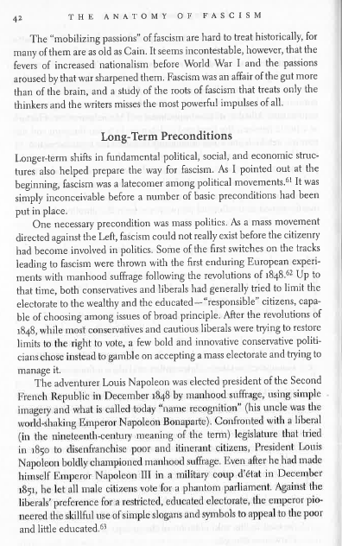
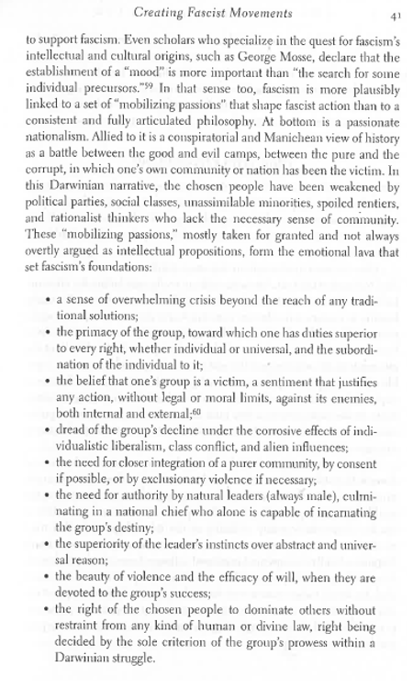
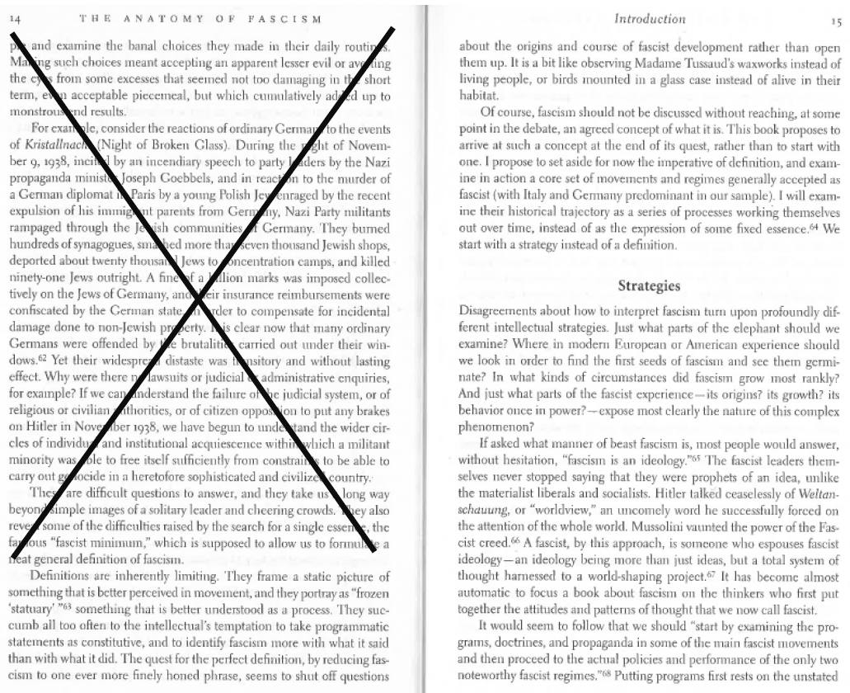
Article 2: Strategies of Fascism
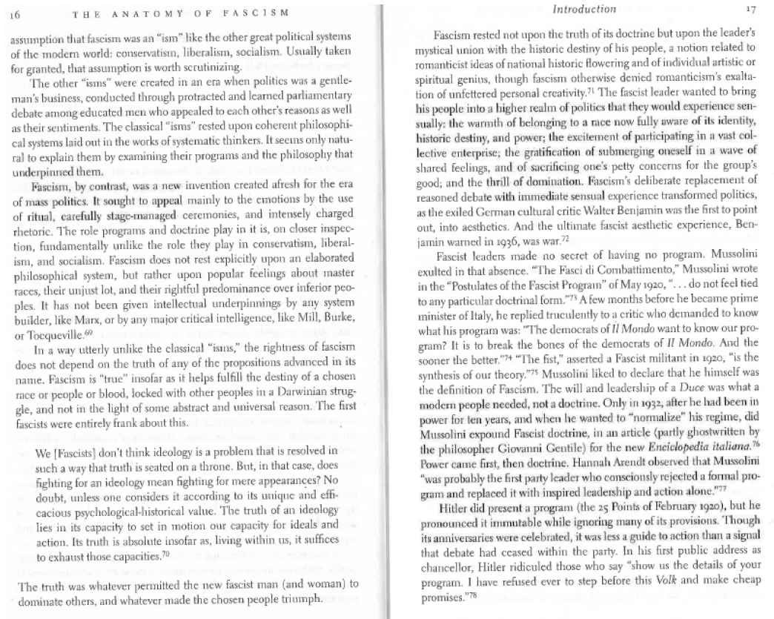
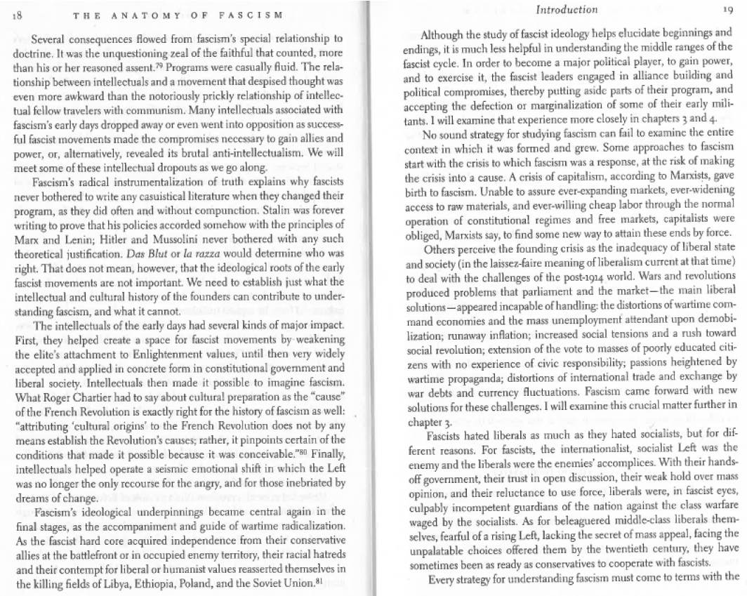
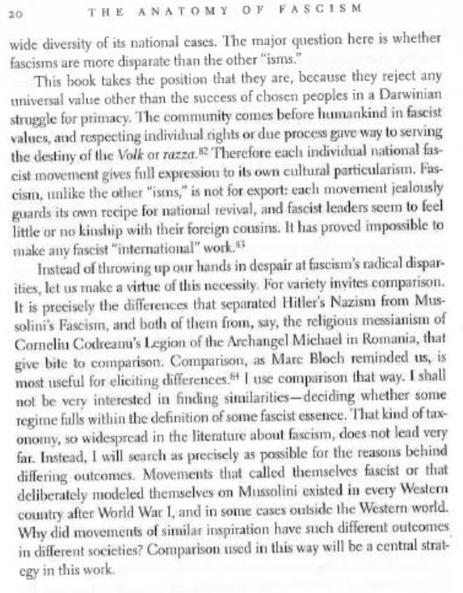
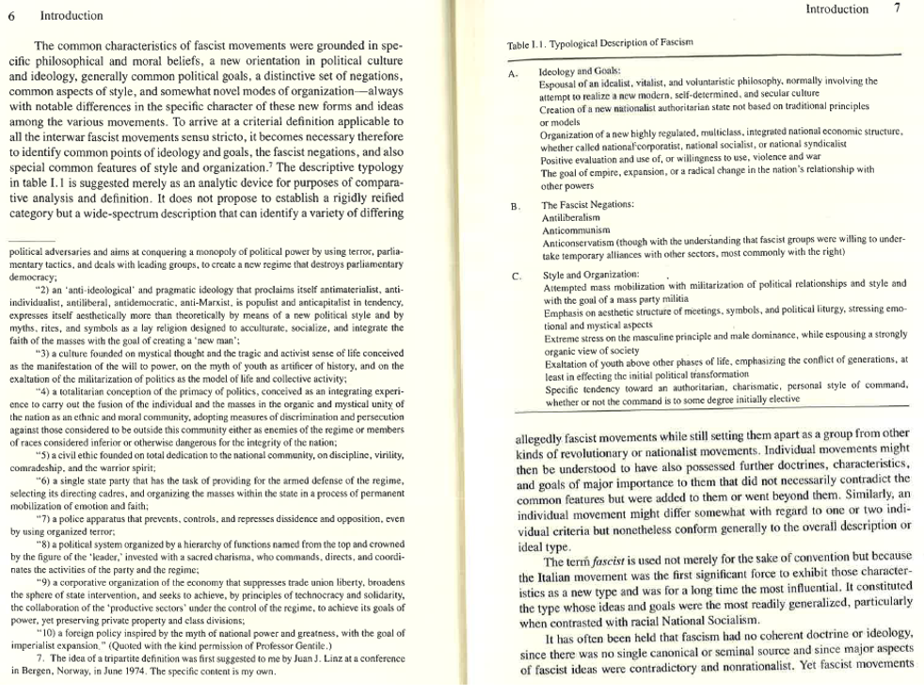
Article 3: Common Characteristics of Fascism
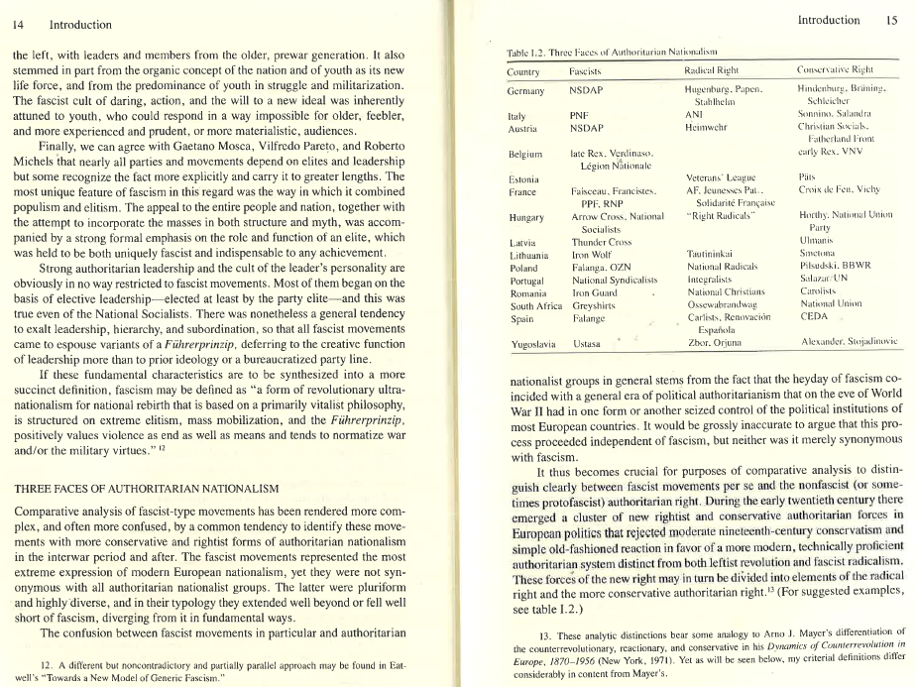
Article 4: Three Faces of Authoritarian Nationalism
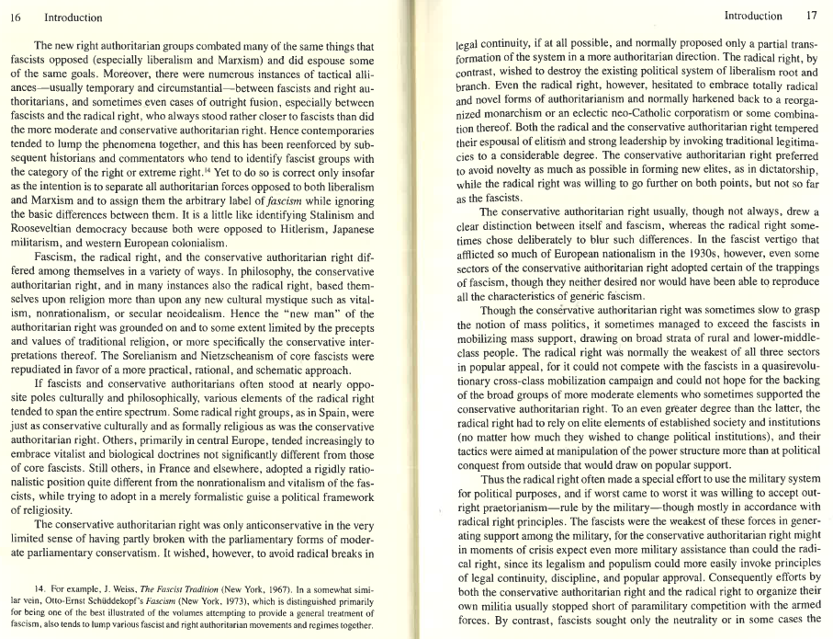
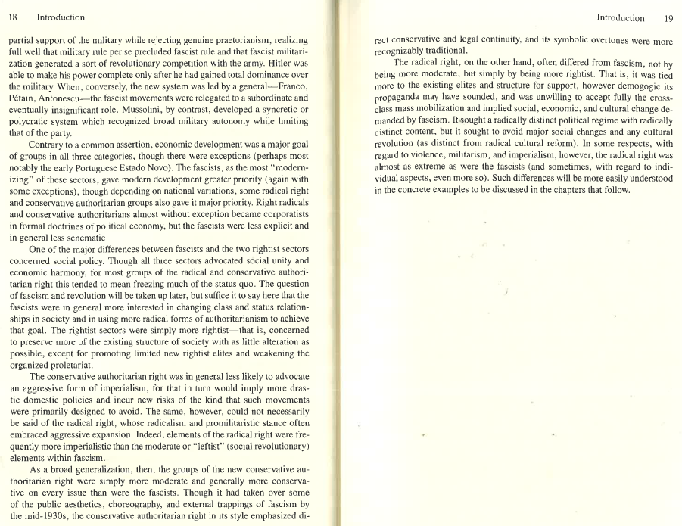
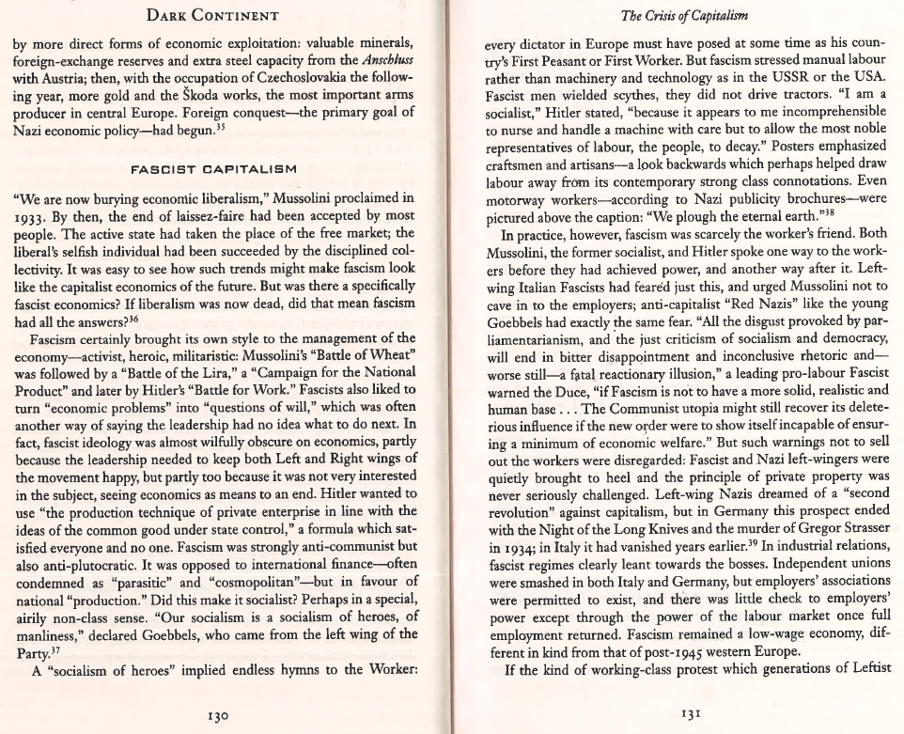
Article 5: Fascist Capitalism
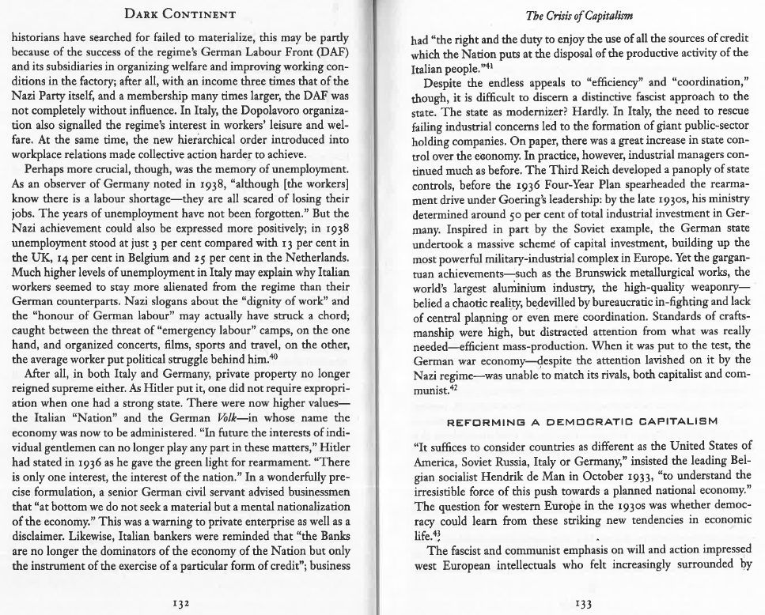
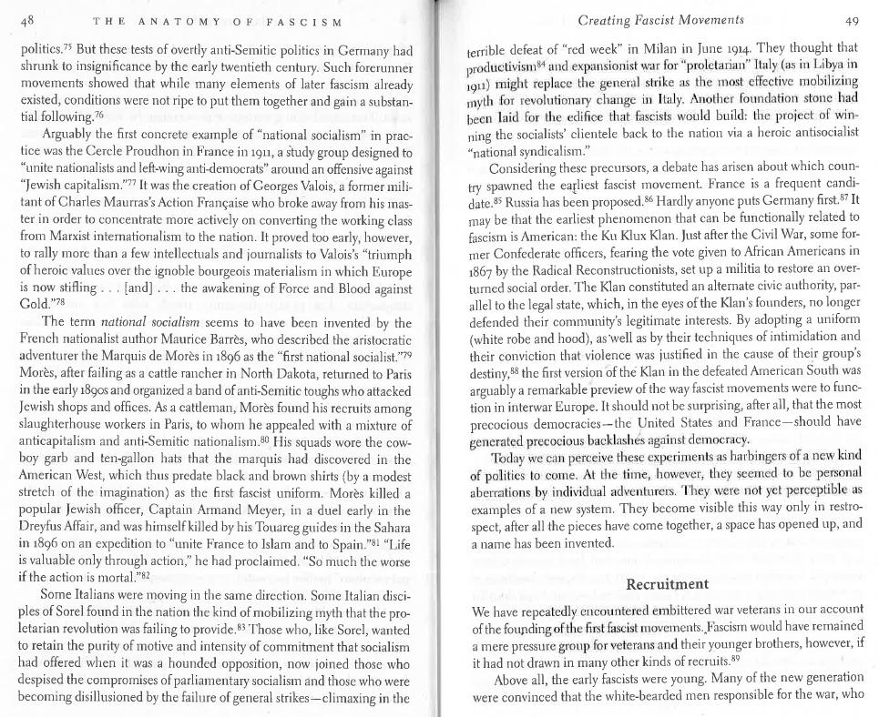
Article 6: Developing Fascism
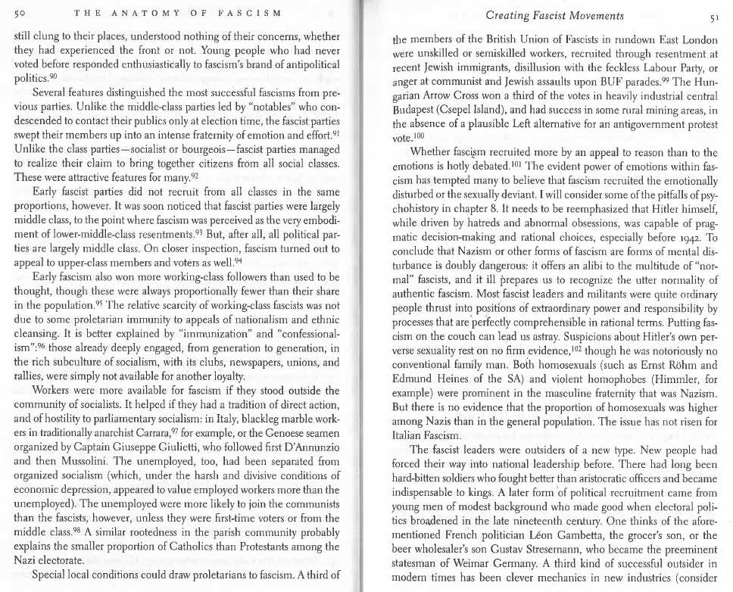
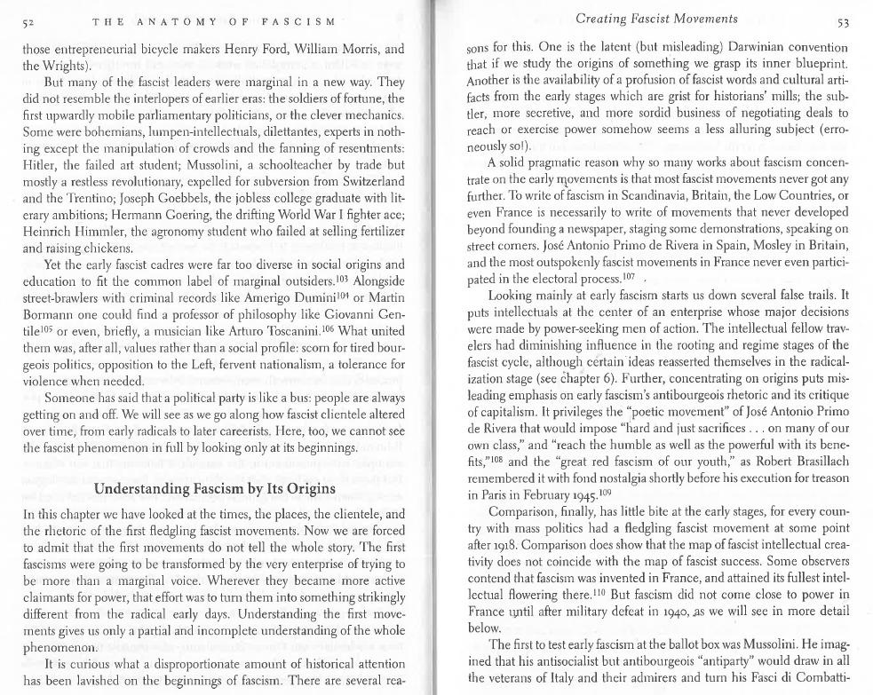
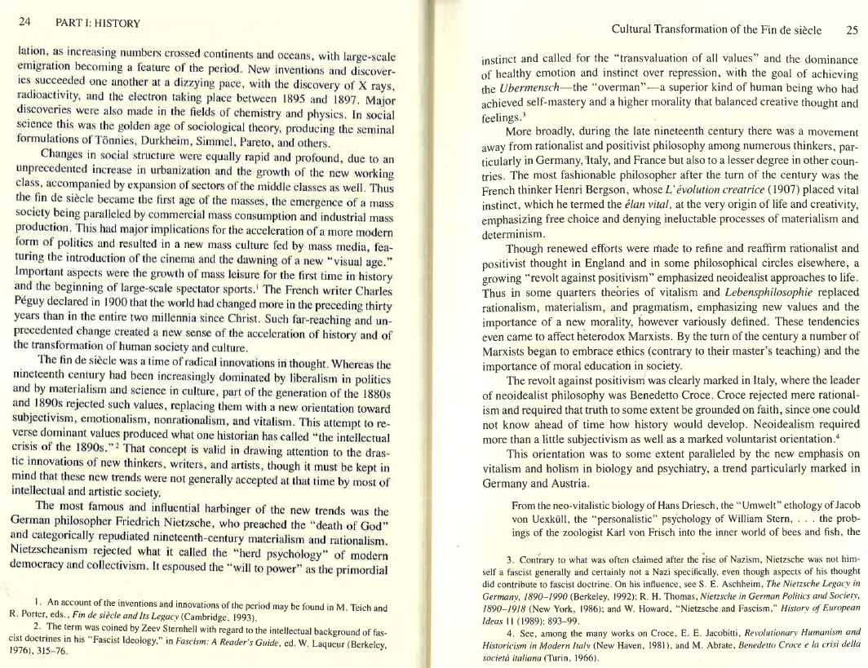
Article 7: Fin de siècle – needed to understand Retrodictive Theory of Fascism
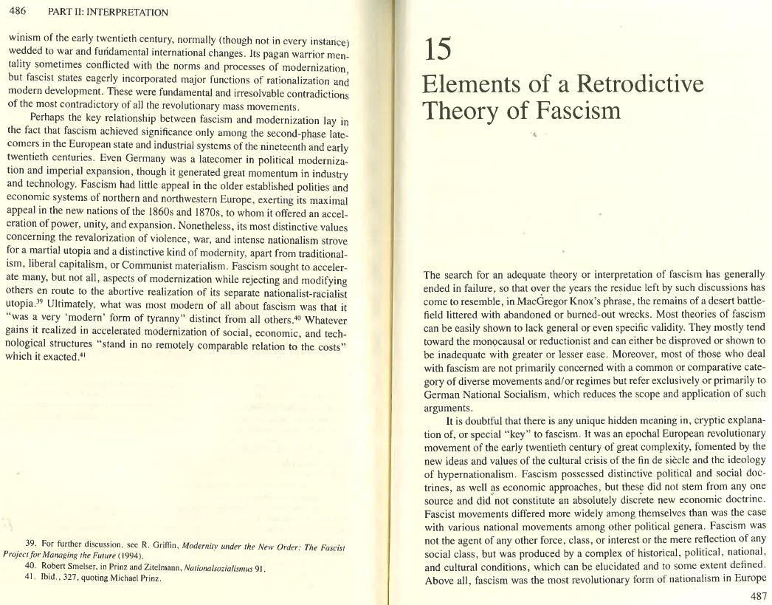
Article 8: Retrodictive Theory of Fascism
