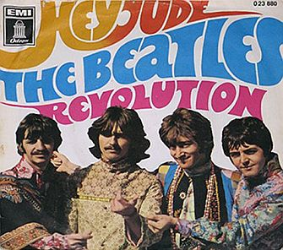
After the Industrial Revolution Isms

First, you and your group will be assigned an ISM to come out of the Industrial Revolution. You will then practice your research skills to find out about your topic in this era. Did the picture of the album cover make you happy? Any ideas how it relates to the learning of Isms in history class? Read on…

Next, your group will form a band and create an album (hence the picture of the album above) based off the information you learned about your Ism. Your album must include:
- Band Name & Album Title
- 8 Song Titles
- A Unified, Artistic, Creative Album Cover
- Lyrics to at least ONE song: Chorus (4-6 lines); Verses (at least 3); Title
  - Also, all of your lyrics will be on the album either on the cover or as an insert.
Brownie points if you can think up a relevant an interesting “producer” and other contributors

AND THEN… The research that your group does on your assigned Ism for the album will turn into a “launch party” – OK, I am just trying to say “informational group presentation”. Your presentation should be comprehensive and should CLEARY cover your Ism.
- You should present this in the form of a thesis showing impact and then backing it up with factual and opinionated data.
- You should talk about the founding documents and informally cite your work in some way.
- Finally, you should make sure to talk about how your Ism is still in operation in World (and in some cases the rest of the world) today and how it relates to your album.
THIS IS NOT JUST READING US YOUR ALBUM INFORMATION! And if we are short on time it may need to be done in a small group jigsaw, so be sure each group member knows information.

Finally, you need to include a MLA Formatted Bibliography for all the sources used for the album and presentation. Please turn this in with your album on a separate sheet of paper with all names included. You will need to do this before I grade your album.
Album  _______ /10 Information regarding your ISM  _______/5 Attention to historic & artistic detail  _______/5 Creativity  This is a 20 point process grade | “Launch Party”–time permitting (otherwise just a small group jigsaw @ 10 points)  _______ /5 Detailed, solid thesis about your Ism  _______/5 Ism facts & analysis  _______/5 Your group’s presentation-general & all members participation  This is a 15 point participation grade

ISMs covered – you will be assigned one:
Chartism & Socialism
Communism (in pure sense)
Conservatism
Feminism
Utilitarianism

