TOK: Internal Assessment / Oral Presentation
General Assignment Description
Refer to the TOK Subject Guide, p. 9, pp. 55-58 for guidelines, and then pp. 63-64 for assessment criteria. The presentation is worth 1/3 of your overall TOK mark.
The topic for your presentation may be on any real-world topic that has the potential to meet the primary demand of the assessment criterion – the exploration of knowledge issues. Presentations may take any forms, such as lectures, skits, simulations, games, dramatized readings, interviews, or debates. But remember, you must not merely present sides of a viewpoint or explain the arguments on a debatable topic. You must show depth of thinking on a knowledge issue. Related individual presentations and interactive presentations are highly encouraged. Take the time to create an interesting presentation. Lectures can be dreadfully boring.
Objective: The presentation requires you to analyze a real-life situation or contemporary problem of global significance in a way that demonstrates a knowledge issues and answers a knowledge question.
Knowledge Questions for assessment purposes:
Directly from IB:
Knowledge questions that are most likely to support high levels of achievement are:
1. Open-ended questions that admit more than one possible answer
2. Explicitly about the formation of knowledge in itself and not [simply] subject-specific claims
3. Couched in TOK vocabulary and concepts: the areas of knowledge, the ways of knowing, and [knowledge issue concepts such as] belief, certainty, culture, evidence, experience, explanation, interpretation, intuition, justification, truth, values.
4. Precise in terms of the relationships between these concepts. To item #3, we would add concepts such as perspective/bias, reliability, validity, limits, paradigms/worldviews, assumptions, proof, verification, etc.

Time: Your oral should be not more than 10 minutes. Groups of three will plan for 25-30 minutes maximum. There is no formal penalty for a short presentation, but it’s a fair bet that short presentations will have missed some important steps. There may be time for questions/discussion following your presentation, but this does not count in your overall time or in your evaluation.
Real-life situation / contemporary problems: A successful topic will be specific and concrete, rather than abstract, theoretical, or general. These are to be “real-life situations,” not examinations of big philosophical questions (e.g., “Do human beings have free will?”). It must be a topic that lends itself to different perspectives and to which you can make connections in other areas to help demonstrate the topic’s significance. IMPORTANT: Avoid situations / problems that are so complex or unfamiliar that they would require a great deal of preliminary explanation. In other words, a Presentation on string theory as a model for the structure of the universe would be inappropriate: our class doesn’t have the background and you wouldn’t have the time to provide it.
Approach: The most common approach is a straightforward talk, but consider a variety of more creative approaches such as skits, simulations, interviews, debates, etc. Supporting materials such as PowerPoints, videos, posters, recordings, costumes, props, etc., are acceptable, but are not evaluated. PPTs are for structure, sign-posting or visuals; never for text that you then proceed to read aloud.
Supporting materials: In addition to optional audio-visual and technical aids, you should have an outline to help keep you on track. These should be ‘talking points,’ not complete paragraphs which you would simply recite. Quotations from sources can be read verbatim. “Under no circumstances should the presentation be an essay read aloud to the class”. Include your Bibliography with your materials AND as appropriate in your PPT.
Partnering: You may be partnered with up to two other students. In those cases the amount of time for the presentation is extended accordingly to a maximum of 25-30 minutes. You could take on different roles in the presentation, or analyze different perspectives, or focus on different knowledge issues raised by the topic.
Structure: Following the structure indicated below will help ensure that you are delivering a presentation that will address the four assessment criteria. For purposes of illustration, assume a presentation that is 10 minutes in length. Times below are approximate. They give you a good idea of relative emphasis. Expand accordingly for your group size.
Part I: Provide a brief overview of the real-life situation / contemporary problem that your presentation will discuss. 2 minutes. (Do not get bogged down in this part!)
Transition: State your Knowledge Issue question. 30 seconds.
Part II: Explore and develop your KQ in terms of how knowledge is constructed/confirmed. 1 minute.
Part III: Analyze & apply your KQ to the real-life situation, explore other knowledge implications. 4 mins.
Part IV: Discuss implications in related areas (other real-life situations, fields of study, etc.) 1 minute.
Part V: Conclude by asserting the overall significance of the topic. 1 minute.
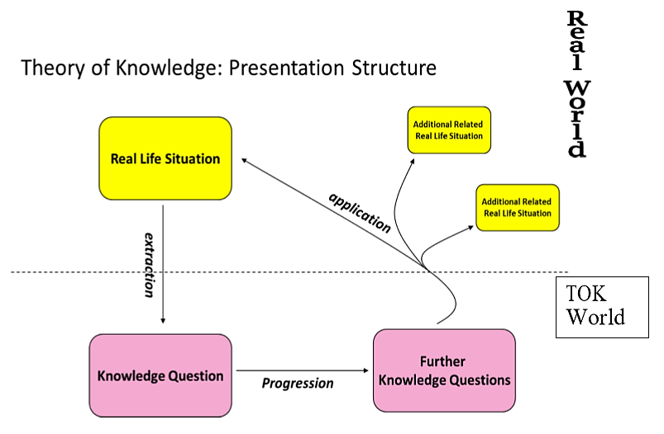
Required documentation for IB:
1. IB-Required: Presentation Planning Document: (TK/PPD): You must complete the PPD and submit it to me the next day class meets after your Presentation. The first page is about planning. The second page is about your outline and must include your signature. Evaluation for IB: There are five levels of achievement for the IA. Complete descriptors are in the Subject Guide and in class handouts. You will receive a grade out of 10 for your IA from IB, which is a third of your IB TOK score. The essay you already submitted is two thirds.
Class Grading – the details of each will be expanded on throughout the process:
The central components are:
- The class Proposal & Planner and the IB TK/PPD Planning document [40 points]
- The Script & Outline completion and preparation [40 points]
- The presentation [100 points]
- Daily productivity grades

