HUNGARY HOMEWORK :)

Please read both sources and highlight key points, mark questions you have so you can ask us later during our presentation as we will cover Hungary’s history more in depth.

Revolution in Hungary, 1956
Clip run time: 1 min 34 sec
This footage shows the scenes from Budapest in the wake of the anti-Soviet uprising of 23 October 1956. The voiceover describes the 'heroic revolt' of Hungarian citizens struggling to join the 'free world'. Burnt-out buildings and vehicles can be seen in Hungary's capital in the immediate aftermath of the revolution. Protestors have destroyed the statue of Stalin, the symbolic figurehead of Communism, who had died three years earlier. Sympathetic Italians can then be seen protesting in Rome, hoping that other countries in Eastern Europe would follow Hungary's example and end Soviet control. This period of euphoria was short-lived. On 4 November the Soviets launched what they called a 'counter-revolution' to bring Hungary back within the fold. Imre Nagy, who had formed a coalition government and announced Hungary's withdrawal from the Warsaw Pact, was executed, and thousands of his supporters sent into exile.

**Link to the video below: (username:spartans password:spartans)
http://gateway.proquest.com/openurl?url_ver=Z39.88-2004&res_dat=xri:ho-us&rft_dat=xri:ho:sup_multimedia:vid1282:mpi

, directed by Anonymous . History Study Center, http://gateway.proquest.com/openurl?url_ver=Z39.88-2004&res_dat=xri:ho-us&rft_dat=xri:ho:sup_multimedia:vid1282:mpi. "Revolution in Hungary, 1956.", .

2. Page from "The Collapse of Communism in Eastern European Countries: Poland, Czechoslovakia, Hungary, Romania and Bulgaria." Day, Alan J. and Verena Hoffman, eds.,
The Annual Register for 1989 110-29.

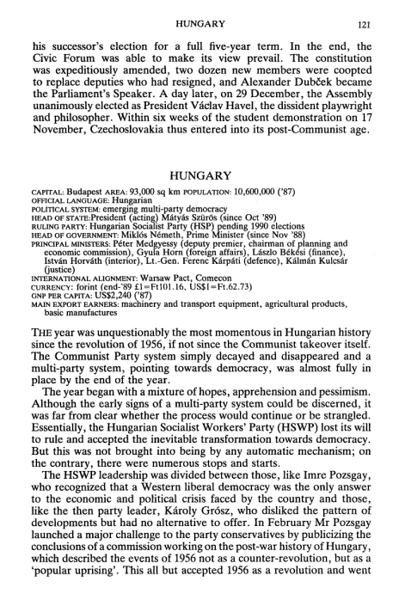
Day,Alan J.and Verena Hoffman, eds. "The Collapse of Communism in Eastern European Countries: Poland, Czechoslovakia, Hungary, Romania and Bulgaria.", 1990. History Study Center, http://gateway.proquest.com/openurl?url_ver=Z39.88-2004&res_dat=xri:ho-us&rft_dat=xri:ho:sup_image:9944:ann.

