This I Believe About Blasey v. Kavanaugh
I believe Blasey deserves to be fairly heard, not automatically believed.
By Bret Stephens
Opinion Columnist Sept. 21, 2018
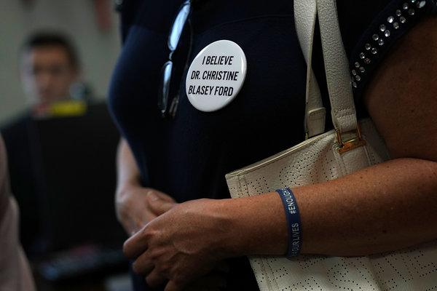
An activist in Washington wearing a button in support of Christine Blasey Ford. Credit: Alex Wong/Getty Images
I have absolutely no idea what, if anything, happened between Brett Kavanaugh and Christine Blasey Ford at a party in Maryland in the early 1980s.
Unless you were at the party, I believe that you don’t, either.
I believe that statements on the controversy that begin, “I believe Blasey,” or “I believe Kavanaugh” — because they jibe with personal experience or align with a partisan motive — are empirically worthless and intellectually dishonest. I believe the defect could be corrected by saying, “I want to believe” Blasey or Kavanaugh.
I believe that when Kirsten Gillibrand says, “I believe Dr. Blasey Ford because she’s telling the truth,” the senator from New York is either deceiving herself or deceiving you.
I believe that the actions of which Blasey accuses Kavanaugh and his friend Mark Judge are grave. I believe locking a young woman in a room, groping her aggressively against her will, and turning the music loud so her cries can’t be heard, isn’t harmless teenage horseplay.
I believe Kavanaugh’s more vociferous defenders should ask themselves how they’d react if that had been done to them or their daughter.
I believe it will not do to defend Kavanaugh with the argument that this was one long-ago youthful mistake in an otherwise upstanding life. Nor will it do to note that his classmates thought he was a great guy. Or that this is the only known allegation against him. Or that, as a judge, he hired lots of female clerks.
I believe the thing that matters now is that Kavanaugh categorically denies the sexual assault allegation.
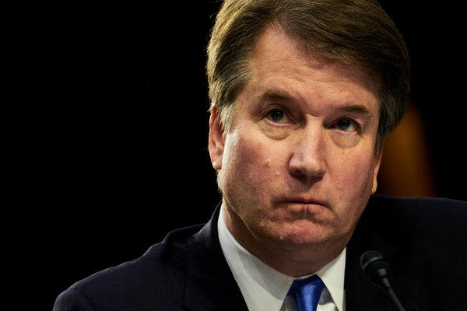
Allegations of sexual assault against Judge Brett Kavanaugh when he was in high school have upended the confirmation process. Credit: T.J. Kirkpatrick for The New York Times

I believe that nobody who sits in judgment of others, whether as a federal judge or Supreme Court justice, should ever be guilty of such an assault at any age, much less of brazenly lying about it as an adult.
I believe in the presumption of innocence. I believe this is fundamental, and that it should apply in courts of public opinion as well as those of law. I believe that sexual assault is evil, but so is bearing false witness.
I believe women lie just as often as men do. I believe the standard “presumed innocent” must always trump the slogan “Believe Women” if we intend to live in a free and fair society.
I believe that Blasey has a moral obligation to demonstrate, as best as she can, that the serious charge she has brought against Kavanaugh is true. I believe that if she fails to do so, after having reluctantly but voluntarily come forward, she will have smeared Kavanaugh.
I believe that Blasey has yet to offer definitive evidence of what she alleges. Notes taken by her therapist that an unnamed man loosely fitting Kavanaugh’s description are marginally corroborative but not dispositive. The same goes for polygraph exams, which is why they are rarely admissible as evidence in court.
I believe human memory is imperfect. I believe it deteriorates over time. I believe most of us have had the experience of thinking we remember something clearly, only to discover we got important details wrong.

I believe I might be mistaken about this. A recent op-ed in The Times argues that we tend to remember traumatic incidents quite vividly. I believe that if this hypothesis is correct, then Blasey should be able to provide a wealth of information about the attack and the circumstances surrounding it.
I believe the F.B.I. should be given a few days to conduct an investigation before a Senate hearing for Blasey is held. I believe that following the precedent set by George H.W. Bush during the Clarence Thomas hearings is reasonable and should not push a vote beyond the midterms. I believe this is important for the Senate to fulfill its advise and consent function.
I believe that since Blasey’s lawyers have demanded an investigation, their client should be expected to provide specific information about the alleged attack that can be corroborated independently. On Tuesday, The Times reported that Blasey “has been uncertain about some details of the episode, including when it happened and whose house they were at.”
I believe Blasey’s credibility will be tarnished if she can vividly recall the unverifiable parts of her story, but not the ones that can be verified. I believe Kavanaugh deserves to be accused of actions he can potentially disprove, not merely deny.
I believe whatever report the F.B.I. produces will be imperfect. I believe that a Senate hearing, whatever form it takes, will be imperfect. At this point, I believe every conceivable alternative is worse.
I believe Merrick Garland was treated despicably by Senate Republicans. That’s beside the point here. I believe Dianne Feinstein has behaved recklessly. There’s no undoing the mess she’s made. I believe there may be a meta-message in Blasey v. Kavanaugh. But the only thing that matters now is to try to discover the truth of what happened when they were teenagers.
I believe in letting the chips fall where they may. I believe the republic will survive either way.

